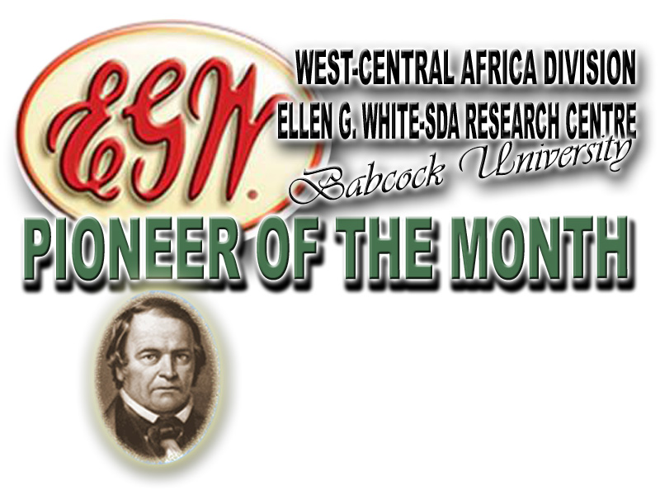

As one of our publications, pioneer of the month brings to you from time to time
brief accounts of some of our Pioneers who had laboured in God’s Vineyard.
This month, we present a servant of God,

ISRAEL TETTEH AGBOKA
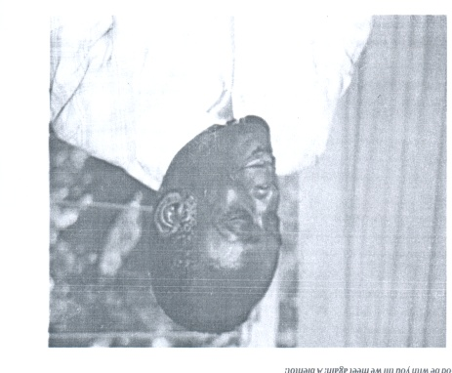
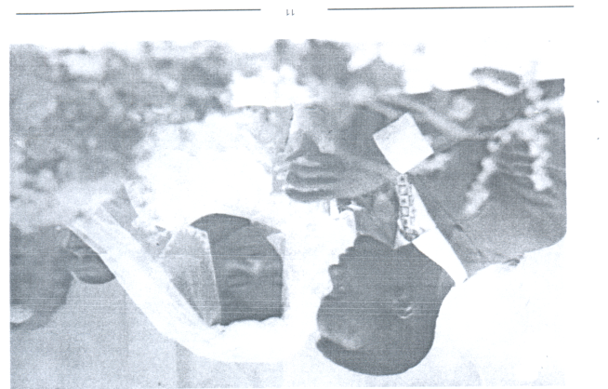
(JULY 6, 1937 - OCTOBER 9, 2005)

His Early Life: The great man, Israel Tetteh Agboka, was born on July 6, 1937 in Bekwei-Ashenti to late Pastor David Netter and Shepherdess Eunice Buerkuor Agboka. As a child, his parents took him and his elder brother to Accra at his four years of age when his father was transferred for the furtherance of God’s work in 1941.

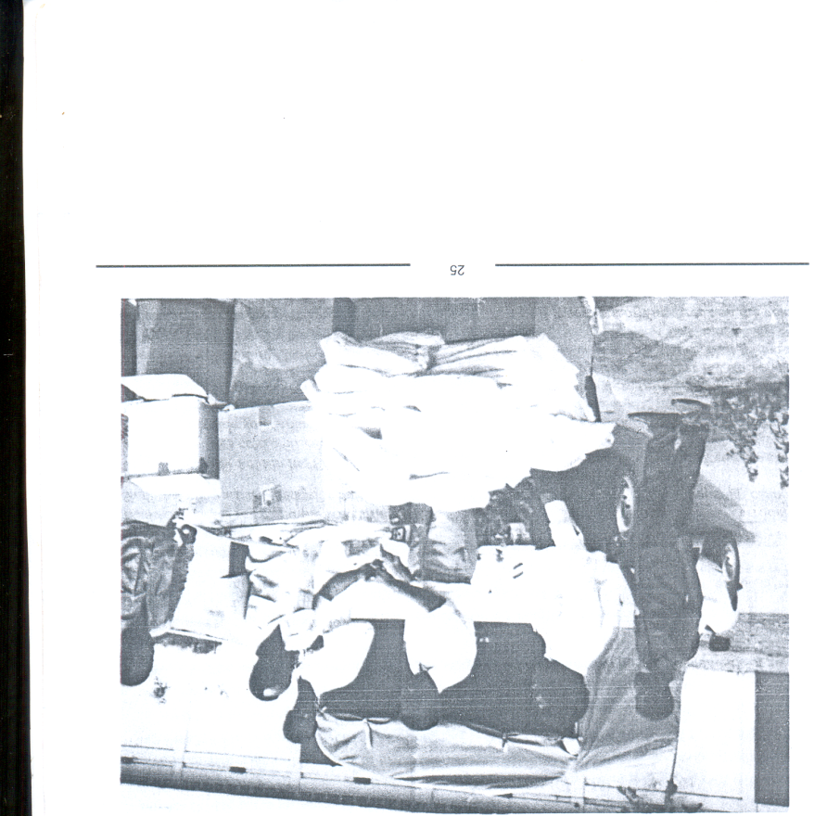
Educational Background: When his parents moved to Accra, he began his elementary education at the then Gold Coast National School, popularly known as Akwei School. As soon as he completed his elementary education in 1953, he got full scholarship award from Ghana government to study at Accra Academy. The offer was however turned down for his father’s choice of Christian education for his dear son, Israel. Therefore, he enrolled Israel in Seventh-day Adventist Secondary School (SDASS) at Bekwei. Although it was the desire of his father to give Israel a sound Christian education, he could not afford the child’s admission fees. This would have obstructed his education program but for Mr. Meberly, the school headmaster, who took it upon himself and sold his daughter's bicycle to balance the admission fee. As a child, who had zeal and quest for education, Israel served as house help for the headmaster to clear the debt and make provision for his subsequent school fees. The boy Israel was submissive, obedient and hardworking. He usually gave all that he earned to his father who, after paying tithe, used part of the money for Israel's school fees, up-keep and of supplement the family’s budget. In his final year, his parents were transferred to Bekwai, he stayed with them and attended school from home. The Lord greatly blessed his efforts so he became the first SDASS student to attend Form 6 from his school.

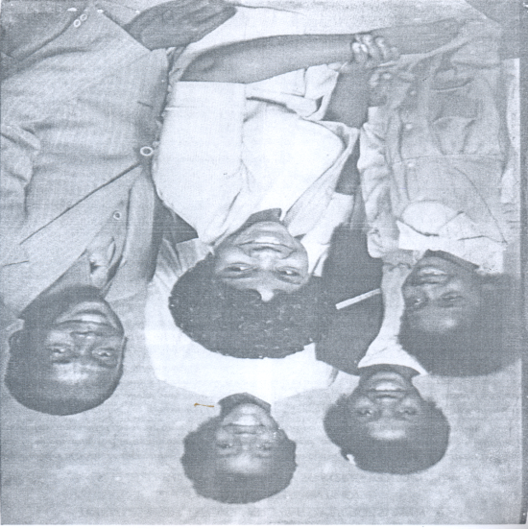
Immediately after Form 6, Israel Agboka furthered his education in Prempeh College, Kumasi, from 1957 to 1959 where he served as the perfect for Ramseyer House. Also, he continued his education at the University of Ghana, Legon, where he obtained his Bachelor of Arts Degree in 1963. After first degree, he proceeded to Andrews University in the United States of America, for his Masters Degree. This was made possible through the Seventh-day Adventist Church scholarship scheme in recognition of his potentials and zeal. In December 1979, he started his Doctorate Degree in the United States.
FAMILY LIFE: The young man Israel, as was transferred from Bekwei where he worked as the Acting Headmaster, to Seventh-day Adventist Teachers’ Training College, Asokore- Koforidua. While in Koforidua, his father requested that Israel visits the father’s Master, F. K. Caesar Esq., in 1966. While on the visit, Israel came in contact with Nora Caesar who later became his wife.

Their marriage was blessed with three precious daughters namely, Elvera, Linda, and Donna. They (the daughters) are happily married to Alfred Sesay, Fred Lokko and Dan Tei-Menseh Tanihu respectively.

WORK HISTORY: When he returned from US, with his master degree in 1965, Israel had his first job appointment in his Alma-Mater, SDASS where for one year, he thought and acted as the Headmaster. At the end of his one year service in SDASS, he was transferred to the Seventh-day Adventist Teacher’s Training College Asokore where he served as the Principal for 10 years. During this period, he was the youngest Principal in the country, and but he was very humble and wise to learn a lot from the experienced principals like his mentor, Prof. Alex A. Kwapong, the then Vice-Chancellor of the University of Ghana, Legon. These attributes and golden opportunities helped him to climb to the zenith of his carrier.
While studying for his Ph.D in the United States of America in 1981, Israel was invited to serve as the Registrar to the Adventist Seminary of West Africa (ASWA) now Babcock University. While in ASWA, he became the Vice Principal for Academic Affairs.

He left Nigeria to Ghana, his home country, in 1988 to become the pioneer Country Director of the Adventist Development and Relief Agency (ADRA). He held the position until1994. After this, he served in many other capacities, such as: Chaplaincy, Campus Ministry, Estate and Development, Spirit of Prophecy/Voice of Prophecy and as Education Director at the Headquarters of the Seventh-day Adventist Church, Ghana Union Conference till 2002 when he honourably went on retirement. He was a very hard working and competent servant of God.

One thing Israel so loved was to work for his Lord. For that reason, he pastured Meteheko SDA Church for one year. Also while on retirement, he continued playing vital and active roles both at the Prince Emmanuel Seventh-day Adventist Church and other neighboring churches. Throughout his life, he consistently impacted people, especially in areas such as: Christian Education, Youth Development and Church Growth, amongst others.

His Last Days: After Israel had a cardiac surgery in 2002, he could not recover fully. On several occasions he struggle with death but the Lord kept upholding him until the dawn of October 9, 2005 when it pleased the Lord to call His faithful servant to rest from his labours.

SOURCE:
Israel Tetteh Agboka (2013). Biography was retrieved from his daughter. Edited by Fagbe Abimbola O. (The former Research Assistant, Ellen G. White-SDA Research Centre, Babcock University), August, 2013.

Ellen g. White-SDA research centre’s
Mailing Address: PMB 21244 Ikeja, Lagos, Nigeria
E-mail: egwsdarc@babcock.edu.ng; egwsdarcbu2014@yahoo.com
Director: Adelowo Felix Adetunji, Tel.: +234 8033705097; 80720290189
Research Assistant: Chinwe Comfort Chinanu-Akpuh, Tel.: +234 8034969753
Administrative Officer: Oyewole Akintunde, Tel.: +234 8028347214

