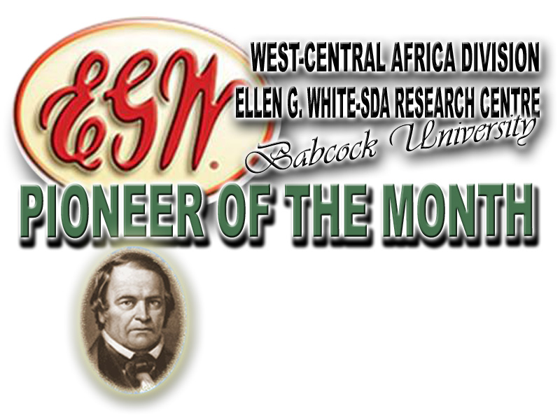

As one of our publications, pioneer of the month brings to you from time to time
brief accounts of some of our Pioneers who had laboured in God’s Vineyard.
This month of june, we present a servant of God,
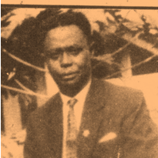

PASTOR SAMUEL APPIAH DANKWAH
(November 8, 1910 – October 25, 1997)

HIS EARLY LIFE: Samuel Appiah Dankwah, fondly called Kwaku Gyekye, was born on November 8, 1910. The parents were Late Mr. Opanin Kwame Appiah and Late Mrs. Obaa Pan who hailed from Adwoa Mante, in Osiem, Eastern Region of Ghana.
EDUCATIONAL BACKGROUND: The young Samuel did his standard one to standard seven at Osiem Methodist Primary and Koforidua Methodist Senior School respectively. As soon as he was through with is elementary education, his outstanding performance got himself an employment as a Ward Assistant at New Tafo Clinic and he worked there for three years. He moved to Bunso and worked as Toll Collector for a while but for lack of job satisfaction, he decided to learn a trade. His vision came true when he enrolled to learn tailoring and that lasted for three years. Samuel Appiah Dankwah practiced this trade from 1935 to 1939 and was at the same time, greatly involved in God’s work. The commitment made him to became an Adventist pastor in 1937, while still in his tailoring business.
FAMILY LIFE: In 1937, Pastor Samuel Appiah Dankwa got married to Madam Yaa Darkwaa, while in active service as a Minister of Adventist church. His marriage was blessed with two children, who died at their early years. Later, pastor re-marriage on July 4, 1935 with Mrs. Elizabeth Appiah Dankwa, (a.k.a) Adwoa Owusuaa, who remained his wife till death parted them.
MINISTERIAL HISTORY: Samuel Appiah Dankwah loved reading, and was a devoted member of Osiem Methodist Church. He later joined the Saviour’s Church of Ghana and was appointed the Church Secretary. While discharging his duties, he developed his reading habit and read mostly, inspirational books. Little did he know that through this reading adventure, he would be led to read some Adventist inspirational books, especially, Ellen G. White writings. The salvation messages from the books led him to accept Jesus as his Lord and Saviour. Dankwa immediately shared the light with his close associates such as: late Opanin Daniel Nkrumah, (Opanin Yaw Nkrumah), late Charles Boadu, (Opanin Kwasi Asare), late Opanin Kwaku Agyei, and late Opanin Odigidigi. The Holy Spirit convinced these friends and they all embraced the Seventh-day Adventist doctrines and joined the Church.
At this point, had more desire for the light they received. Therefore, they sent a five-member delegation for a discussion and clarification with the then President of Seventh-day Adventist Mission in Ghana, Pastor J. A. Clifford. The President was invited to Osiem for series of in-depth Bible studies and discussions. When the president got convinced of what the Lord has started with Pastor Samuel Appiah Dankwah, he approved his employment as a Teacher- Evangelist by the Seventh-day Adventist Mission in July 1939. He was then posted to Wiamoase in Ashanti, to start his ministerial Work. Through hard work and dedication to duty, he was ordained into full ministry in 1951 by Pastor J. O. Gibson, the then President of Ghana Mission of Seventh-day Adventist.
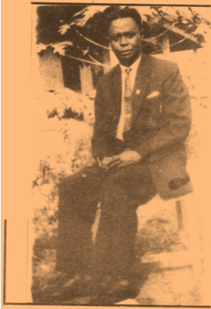
CONTRIBUTION TO THE CHURCH: Through pastor S. D. Dankwa’s counsel and leadership, the church put up a magnificent temple for the Lord, and also bought some glamorous choir robes at Kumasi Metropolitan Area. He was pastore in the following churches at different times; Agona Ashanti, Techiman, Brong-Ahafo, and Koforidua in the Eastern Region. Through God's guidance he led Osiem SDA Church to open new churches at Ettokrom, Maase, Old Tafo, and Anyinasin. He started the Osiem SDA Church Singing Band which is booming with dynamism and is now rated as one of the best singing groups in Ghana Seventh-day Adventist circle. This Church Choir became what it is today as pastor Samuel took the initiative of inviting good song composers and singers like Brothers Asare Bediako and Kwaku Agyemang from Kumasi to teach them many of their scintillating songs. And by God’s mercy, the Spirit of God has moved that choir to greater heights. The Administration and leadership of the South Ghana Conference also testified to the good works of Pastor S. A. Dankwah was inspiring. In the Gospel Ministry, he proved himself, in all spheres, a good leader. He was productive and indispensable. Perhaps, he was one of those who thought “it was better to wear out than to rustout” Indeed, "great men are not great in their own estimation.” His family, fellow ministers, relations and close acquaintances bear positive record of his spirituality and integrity.
RETIREMENT AND LAST DAYS: Late Pastor Samuel Appiah-Dankwah retired from active service in April 1975. He was appointed a Church Pastor at his hometown Osiem, in the same year. His service to the church after retirement was a blessing to the entire SDA Church and the people of Osiem and her environs. Through his Gods-given gift of leadership and wisdom, he instructed many to turn from their wrong ways, the broken hearted got relief and weakened hands were strengthened in the Lord. His teachings from the Word of God were unique. By God's grace, Pastor Samuel Appiah Dankwa was called to rest by the Creator in his home after a brief illness on the Sabbath morning of October 25, 1997.
Source:
Dankwah, S. A. (2013) Biography was retrieved from Burial and Funeral Service program held at Osiem Seventh-day Adventist Church on Sunday 23rd November 1997. Edited by Fagbe Abimbola O. (Former Research Assistant, Ellen G. White-SDA Research Centre, Babcock University), August, 2013:

Ellen g. White-SDA research centre’s
Mailing Address: PMB 21244 Ikeja, Lagos, Nigeria
E-mail: egwsdarc@babcock.edu.ng; egwsdarcbu2014@yahoo.com
Director: Adelowo Felix Adetunji, Ph.D. Tel.: +234 8033705097; 80720290189
Research Assistant: Chinwe Comfort Chinanu-Akpuh, Tel.: +234 8034969753
Administrative Officer: Oyewole Akintunde, Tel.: +234 8028347214

