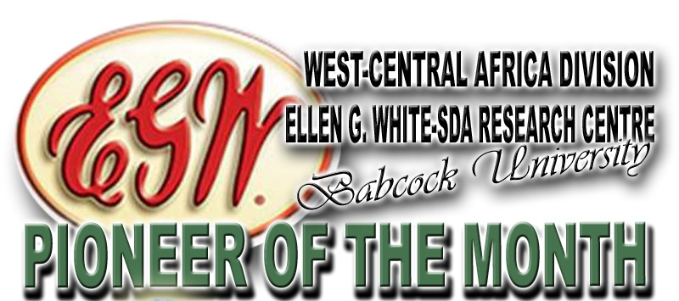
As one of our publications, Pioneer of the Month brings to you from time to time
brief accounts of some of
our Pioneers who had laboured in
God’s Vineyard.
For the month of August,
we present a servant of God,
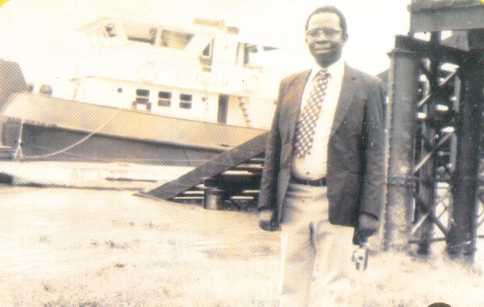

Pastor Eregare James Onorakpene
(May 7, 1936 – June 16, 2013)

FAMILY BACKGROUND/EARLY LIFE: The great man in focus for the month, James Eregare was born on May 7, 1936 to a polygamous home of Pa Eregare at Oruerakpo in Agbon Kingdom of the Ethiope East Local Government Area of Delta State, Nigeria. Pa Eregare; his father, had five wives and seventeen children. His mother was Madam Orhowvigho Eregare, who had four Children for her husband and they were; Pa Patrick Eregare, Madam Akwveyerun (nee Eregare), London Eregare and James Eregare. James was his mother’s third child and he loved his mother so dearly. He had interest on going to the stream and also loved nature. Unfortunately, James lost his father, Pa Eregare in 1942 when he was just nine years old. This occurrence cut short some of his early years activities, as this sudden tragedy imposed a struggle on his survival. While battling with life activities in the village, one of his elder brothers took him to Okitipupa in Ondo State to live with him. From there, he began his formal education.

EDUCATIONAL BACKGROUND: James began his educational career at Saint Paul Primary School, Okitipupa, Ondo State. He completed his standards 1 to 6 at Okitipupa in 1953. In 1955, he attended Teachers’ Training college (TTC) and finished in 1956. After that, he got his first job and worked for a period of time and then returned back to Adventist Secondary School, Bekwai, in Ghana, where he obtained his West African School Certificate in 1960. He furthered his education to Adventist College of West Africa (now Babcock University) where he received his GED Certificate in 1962. He then gained admission into Oakwood University in 1973 for his Bachelor of Arts program but could not attend for financial reasons.

MARRIAGE: Pastor Eregare met his dear wife in his home town. He made his intentions known to her and both of them agreed and accepted each other. As the Lord had it, on the twelfth day of June 1965, they got married and God blessed their union with four children. They are;
- Blessing Eregare-Okorodudu,
- Janet Eregare-Solesi,
- Dr. Emmanuel Eregare
- Edafe Eregare
Pastor James Eregare had in-laws and grandchildren to the glory of God.

CHRISTIAN EXPERIENCE: Eregare’s first contact with the Seventh-day Adventist Church was in 1954 through a home evangelism series. The home method of evangelism was conducted through a series of home to home visitations. James Eregare was a member of the Roman Catholic Church when pastors Solademi and B. Alabi brought the Seventh-day Adventist message to him. James Eregare was a business man and also was working with UCA company at Okitipupa. Having gone through the thorough study of the series of Bible lessons, he became convinced of the Sabbath message. Before he accepted baptism, he decided to consult his parish priest on the Sabbath message and his parish priest confirmed that the Sabbath is Saturday. Without much delay, based on his personal conviction and the confirmation of the Sabbath truth by his parish priest, Eregare got baptized immediately in 1955. That same year, he attended Otun Teacher Training College, Otun, (now in Ekiti State) in Nigeria to prepare him for the ministry.

WORK EXPERIENCE: James Eregare did his first job in 1956 as a hospital Chaplain at Seventh-day Adventist hospital, Lagere, Ile Ife, now in Osun State. In 1957, he got a call to work in Benin City as pioneer missionary with Pastor S.A. Majolagbe where they carried the Adventist message to the Benin people.
James and his colleague were the early pioneers to Benin just before the Nigerian independence in 1960. He worked tirelessly with S.A. Majolagbe to form the foundation of what is now Edo Conference of the Seventh-day Adventist in Nigeria in 1958.
In 1968, he was transferred back to Benin City, Edo State from Ugbo land. From 1969 to 1975, he worked as a hospital chaplain and a District Pastor at Ile-Ife now Osun State. In 1976, after the session of the Seventh-day Adventists in the West Nigeria Mission, he was elected into the offices of Lay Activity, Sabbath School, and Youth as the Director, covering the old West and Mid-Western Region of Nigeria. In 1984, he became a potent Executive Secretary to the old West and the Mid-Western Region. In 1985, he was transferred to Ikirun, Oyo State as a District Pastor where he remained until 1986. From 1986 to 1992, he worked at Ilorin, still as a District Pastor. From 1992 to 1999, he worked as a District Pastor in Lagos that is in the former Yaba District, which now comprises about five or six Districts in the present Atlantic Conference of the SDA Church.
Eregare had served in different departments of the Church in the Old West Nigeria Conference with the then Mid-Western Region. He served as Evangelist, Women’s Ministries Coordinator, Sabbath School/Lay Activities Director, Youth Director, and as General Secretary.

SPECIAL ROLES PLAYED: During Eregare’s tenure as Director and Executive Secretary to the church in the Old West and Mid-Western Region, his most outstanding achievement was the inauguration of the Old Dorcas Ministry, now Adventist Women’s Ministry, which is now functioning in great capacity to aid the church and communities in spiritual and developmental activities.
Eregare, in his account, mentioned that about forty(40) churches were planted during his ministry until he retired in 1999.
To the glory of God also, another significant event of James Eregare’s ministerial work was the mass conversion of the majority of Ugbo people. Pastor Eregare was sent to this community as the first Seventh-day Adventist missionary. He had barely any members until he passed a test unknown to him. Historically each pastor that had previously been sent to this community engaged in sexually promiscuous relationships with his members. Thus, the community church had no pastor for a while. Upon Eregare’s arrival, the community thought that they could send young Eregare away by sending to him one of the prettiest girls in the village in order to embroil him in a scandal. Specifically, this young woman came to him nude and attempted to lay with him in bed. Eregare, however, refused her advances to compromise. Rather, than yielding to the temptation, to the surprise of the whole community, he prayed for her. This singular event brought about a mass conversion and the establishment of the Seventh Day Adventist Church in Ugbo community in 1964.
Ugbo community that was dominated by African Church had a changed history in1963 that almost all the members of the community became Seventh-day day Adventists after their encounter with God through Pastor Eregare, even at the King Mafimishebi’s command.
James Onorakpene Eregare was the first Seventh Day Adventist member and clergy from Oruerakpo town and from Agbon Kingdom of Delta State.

RETIREMENT DAYS: Having worked diligently for God, He retired from active service in 1999 after serving the church to the best of his ability and devotion for a period of forty-three years. After retirement, he never ceased working. Rather, he laboured among the Sapele members and his immediate communities until he died on June 16, 2013.
CONCLUSION: To many, our pioneer for this month was a Pastor, a father, a teacher, an initiator, and a leader. In his life time, he was faithful, trustworthy, caring, spiritual, and God fearing. As a pastor, he touched lives within and outside of the Seventh-day Adventist church.

Source: Source: Extract from Biography (burial program August 2, 2013) as written by
The Children; Edited by (Chinanu- Akpuh, Chinwe Comfort and Oyewale Akintunde,), and extra from an article written by Emmanuel Orihentare Eregare, Ph.D.,, 2014 and updated in 2016,

Published
by
Ellen g. White-SDA Research Centre’s
Mailing Address: PMB 21244 Ikeja, Lagos, Nigeria
E-mail: egwsdarc@babcock.edu.ng; egwsdarcbu2014@yahoo.com
Director: Adelowo Felix Adetunji, Ph.D. Tel.: +234 8033705097; 80720290189
Research Assistant: Chinwe Comfort Chinanu-Akpuh, Tel.: +234 8034969753
Principal Administrative Officer: Oyewole Akintunde, Tel.: +234 8028347214

Pastor James eregare’s
PHOTO ALBUM

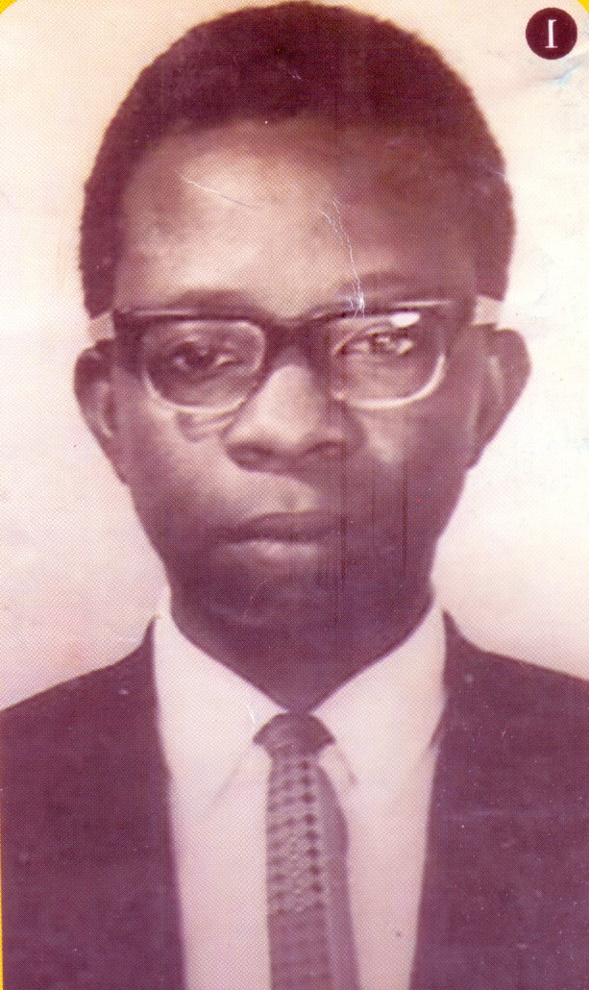

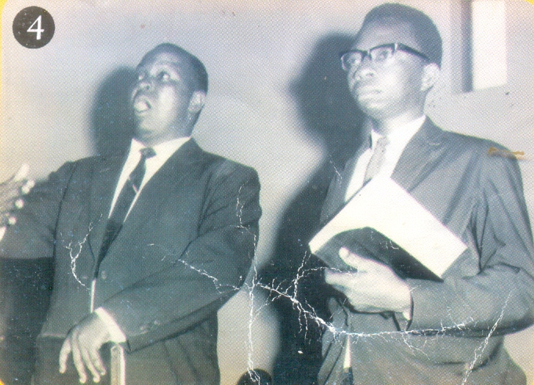 Young Pastor James On Fire for Christ
The brave James Eregare

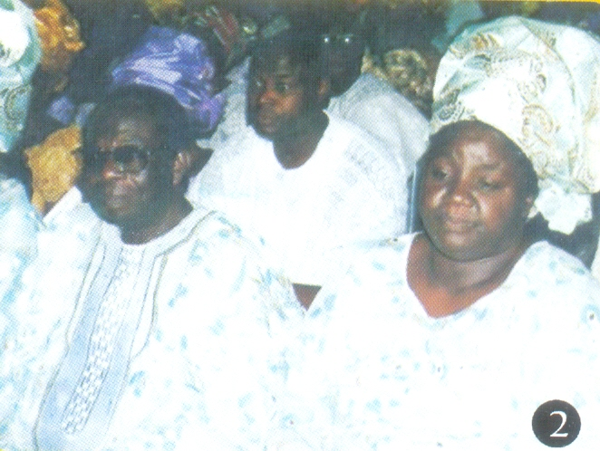
pastor and Shepherdess Ereare at their son's wedding.

pastor's Daughter and her Family

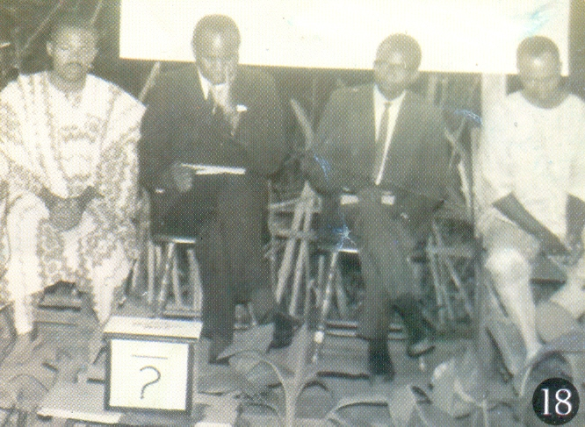
Pastor James on a public Evangelism
Eregare's daughter, Her Husband and Children

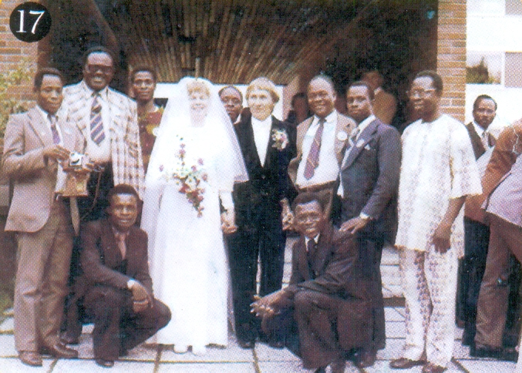
James at his colleague’s wedding
James and his colleagues after Ordination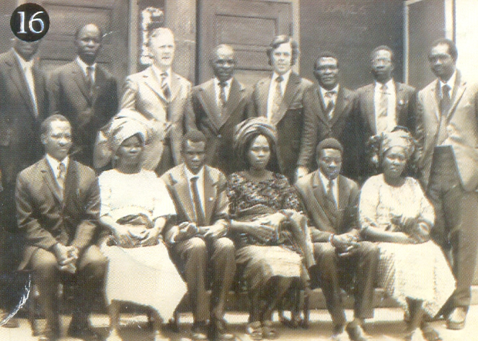

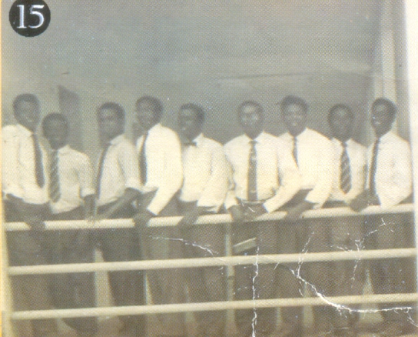
Old ACWA Memories

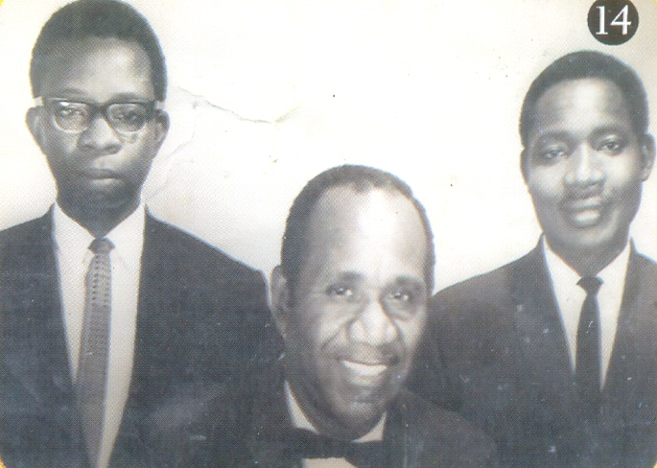
Sweet Memories of Young Pastors

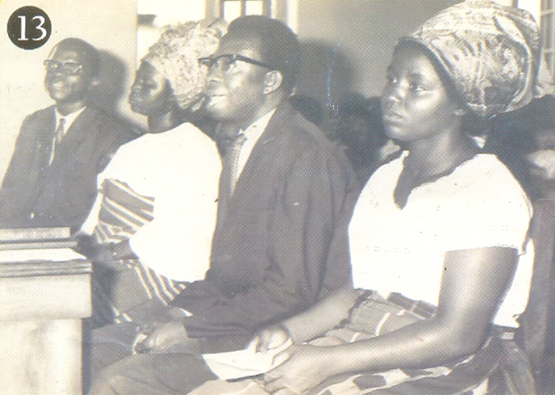
James Eregare's Ordination

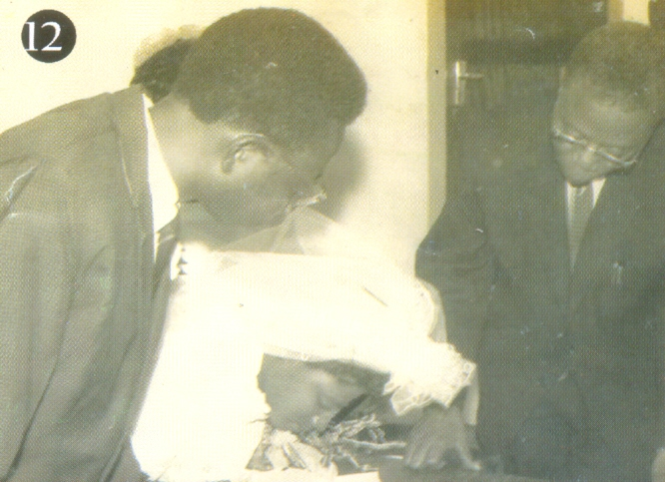
James and his wife on their wedding day signing the register

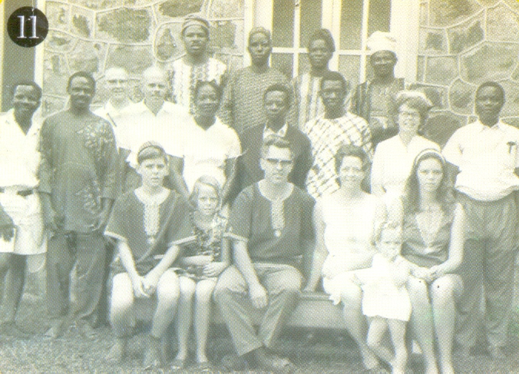
James and his Colleagues at Ife Hospital

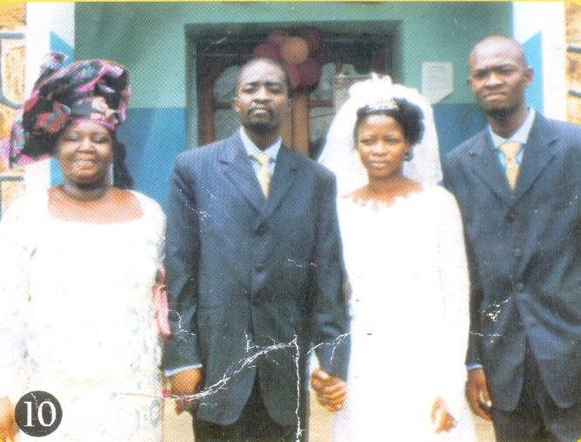
The Eregares celebrating Emmanuel’s wedding
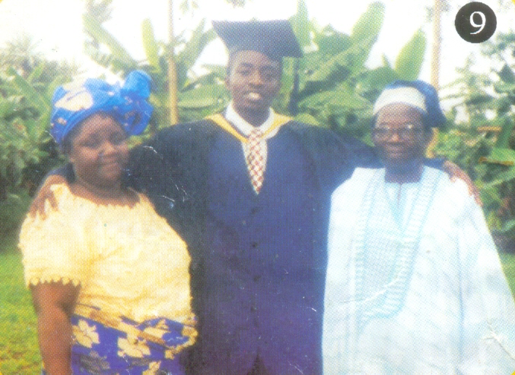
The Eregares celebrating Emmanuel’s Graduation

Pastor James Eregare
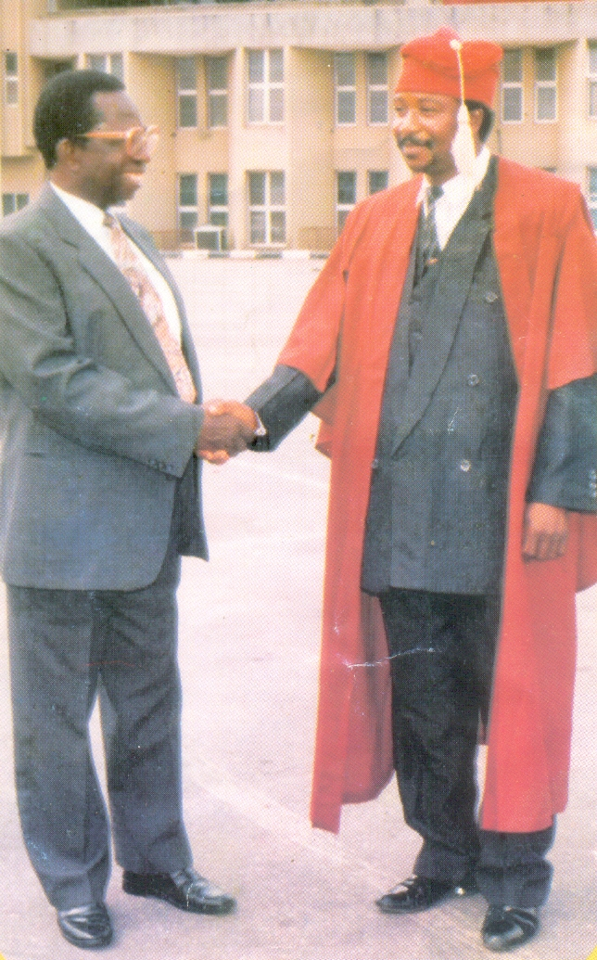
Eregare on His Nephew's graduation

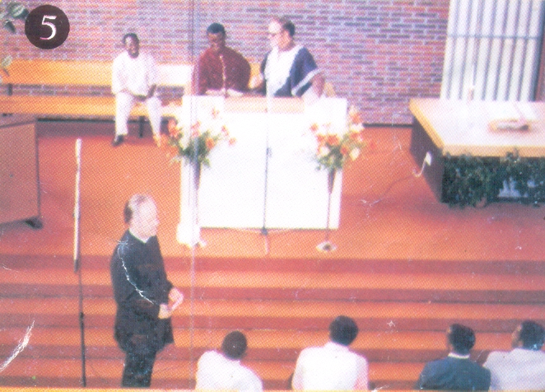
James Ministering on a friend's wedding in Norway
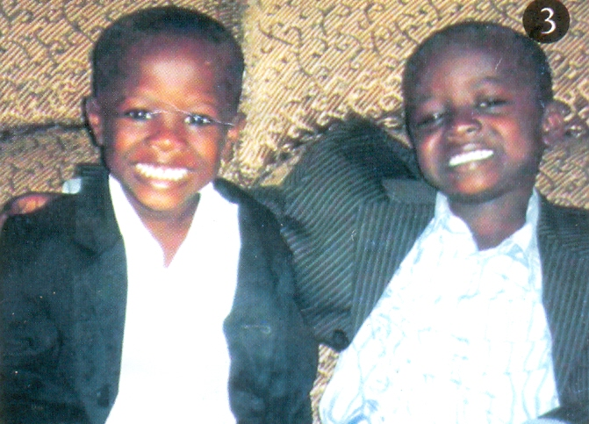
Eregare's Grandchildren

