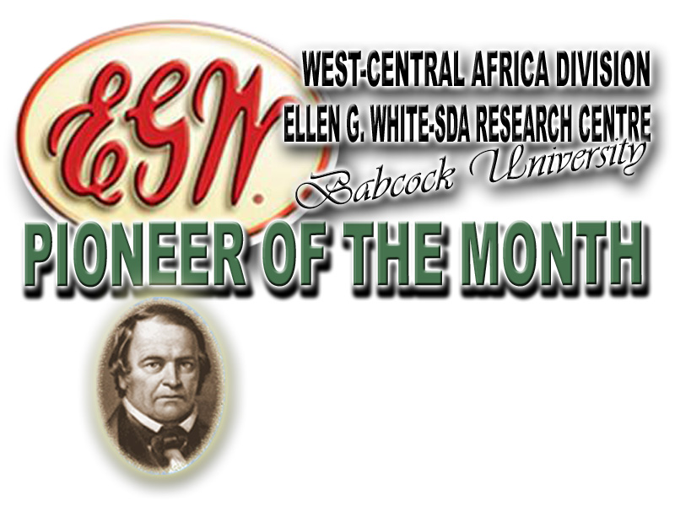

As one of our publications, pioneer of the month brings to you from time to time
brief accounts of some of our Pioneers who had laboured in God’s Vineyard.
This month, we present a pastor and servant of God,

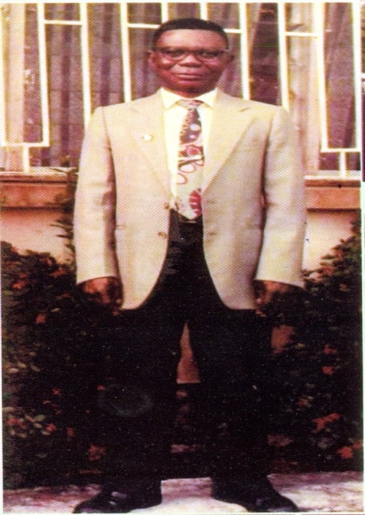

As one of our publications, pioneer of the month brings to you from time to time
brief accounts of some of our Pioneers who had laboured in God’s Vineyard.
This month, we present a pastor and servant of God,

Pastor Isaac Alozie Ekpendu
(June 4, 1931 - December 17, 2014)

Ellen g. White-SDA research centre’s
Mailing Address: PMB 21244 Ikeja, Lagos, Nigeria
E-mail: egwsdarc@babcock.edu.ng; egwsdarcbu2003@yahoo.com
Director: Adelowo Felix Adetunji, Tel.: +234 8033705097; 80720290189
Research Assistant: Chinwe Comfort Chinanu-Akpuh, Tel.: +234 8034969753
Administrative Officer: Oyewole Akintunde, Tel.: +234 8028347214

No: 03 Pioneer of the Month for March, 2015 Babcock University, Nigeria

EARLY LIFE: The great man in focus this month was born on June 4, 1931 to the family of late Elder and Mrs Abraham Ihesiharuka Ekpendu of Umuawa Villiage in Isiala-Ngwa South Local Government Area of Abia State, Nigeria. He was the first and eldest son of the family of nine children. A role model for his siblings, Isaac lived a life of sacrifice for them all.

EDUCATIONAL BACKGROUND: Isaac Alozie Ekpendu began his educational career at the Seventh-day Adventist Primary School, Umuocha where he had his standards 1 to 3 from 1943 to 1946. A brilliant child by nature, he covered his infant 1A, 1B, class 2 and standard 1 in one year that is, 1943. He finished his standards 4 to 6 at the Seventh-day Adventist School Umuobiakwa from 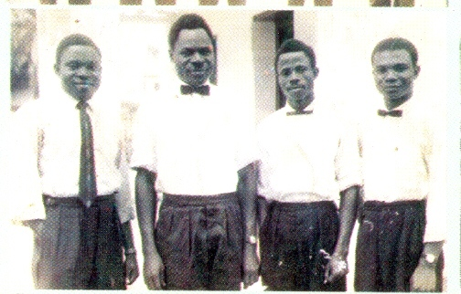1946 through 1949. The then young Alozie bagged his First School Living Certificate with exceptional result that made him one of the best six in his school. He took up pastoral job with SDA Church at the completion of his standard 6 education. From 1950 to 1955, was sent on scholarship to Ihie for Pivotal Teachers Certificate (PTC) by the Church. 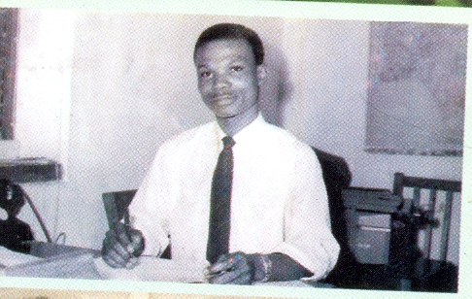 In 1963, pastor I A. Ekpendu took a bold step to join the Adventist College of West Africa (ACWA), where he graduated in June 1967 with a Bachelor of Arts in Theology.
FAMILY LIFE: Pastor Isaac A. Ekpendu had his church wedding with Shepherdess Victoria Ukachi Ekpendu on January 10, 1960. This marriage was blessed with 6 (six) Children, namely: Shepherdess Ngozi Nwachukwu, Mrs. Omoyemi Nancy Emole, Mrs. Ugochi Anaele, Mr. Obinna Ekpendu, Bar. (Mrs) Chituru Onyenmuru, and Pastor (Dr.) Ikechi C. Ekpendu. He also had numerous adopted children. A caring and loving husband, pastor Ekpendu called his wife HONEY. He was all that a friendly father could be to his children and taught them all the way of the Lord. He was a peaceful, loving and soft-spoken, gentle man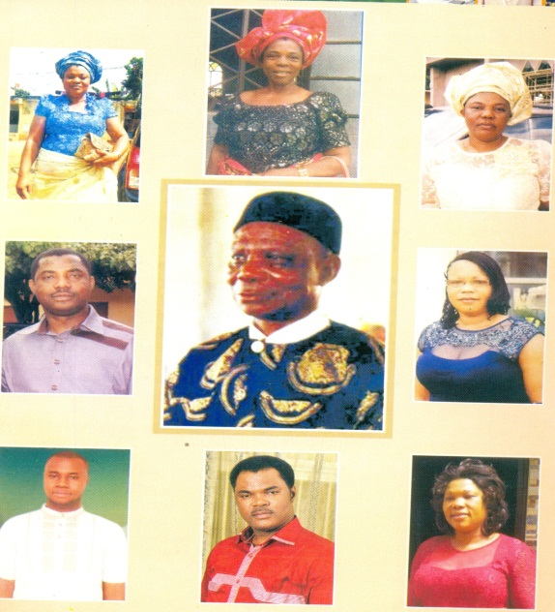

HIS SERVICES TO GOD AND HUMANITY: While pastor was in Umuobiakwa for his standard education, he developed passion, skill and manifested interest in music. His love for music led to his first official assignment as the Umuawa District choir master. He was later opportuned to serve in the first committee to translate Seventh-day Adventist Hymnal to Igbo language (Abu Otito). As earlier stated, he took up a ministerial work in 1950, and began his service in Itungwa.
After his PTC at Ihie in 1955, he was called to work as the Voice of Prophecy Principal in Ibadan. There, he also served as song evangelist for Late Pastor J. Adedigba Makinde, the father of Prof. J. A. Kayode Makinde.
In ACWA from 1963 to 1996, his faithfulness, diligence to duty and creativity endeared him to Pastor Paulson, the former General Conference President. He later sought Pastor Ekpendu’s opinion on how to source for more revenue for the college and pastor Ekpendu suggested bakery. With this suggestion, the bakery started and he was the first baker of ACWA wheat bread. He later became the Chief Baker and Sales Officer as he conveyed the wheat bread to numerous customers in Lagos for marketing. The bakery that pastor started in1963 is what has transformed to the Babcock University bakery of one hundred and three (103) Work-force today.
After his graduation in 1967, he was posted to Port Harcourt as the Principal, Voice of Prophecy. During the war, he served as a Relief Agent that worked with Late Rev. Canon Magnus Adiele from Okpulo-Umuobo. Pastor I. A. Epkendu was later posted to head Okpuhie District, immediately after the war in January 1970. By November of the same year, he was assigned to the then East Nigeria Mission as the Principal Voice of Prophesy. In 1972, he was ordained into the Gospel Ministry and was assigned the 1973 Jubilee coordinator. By the middle of the same year, he was posted to Abakaliki and to Umuahia, in 1975. By 1977, he was elected the first Executive Secretary of Seventh-day Adventist Church in East Nigeria Conference. By 1980, he was transferred to Onitsha, and in 1983 serve in Enugu and 1986 elected the then East Nigeria Conference Director of Voice of Prophecy, Spirit of Prophecy, Conference Evangelist and Stewardship Director respectively. In 1987, he was re-elected as East Nigeria Conference Secretary, where he served under Late Pastor Achilihu. By 1990, he became the first and only Field Secretary for the defunct Nigerian Union Mission, a position he held for five years under Pastor (Dr) Luka Tambaya Daniel (Rtd) as the President. By 1995, he served as Ministerial Secretary and Global Mission Director of the same Union under Pastor Dr. Adebisi Ola. He also held this position for five years and then retired in 2000. Before his retirement, he championed the Union’s roofing project, where hundreds of churches were roofed in Nigeria.
HIS LAST DAYS: During his retirement years, he impacted his community. Pastor I. A. Ekpendu empowered many with the little he was paid for self sustenance; he focused so much on developing people in the area of education. To those who were in his village, he was a vanguard of peace until he was called to rest on Dec 17, 2014.
CONCLUSION: To many, our pioneer for this month was a Pastor, a father, a teacher, an initiator, and a leader. In his life time, he was faithful, trustworthy, caring, spiritual, and God fearing. As a pastor, he touched lives within and without Seventh-day Adventist church and even outside the church.

Source:
Mr. Obinna Udo Ekpendu (2015) Extracts from burial program held on Wednesday 11, 2015.
Edited by:
Chinwe Comfort Chinanu-Akpuh. (The Research Assistant, Ellen G. White-SDA Research Centre, Babcock University, March 25, 2015).

(June 4, 1931 - December 17, 2014)

Ellen g. White-SDA research centre’s
Mailing Address: PMB 21244 Ikeja, Lagos, Nigeria
E-mail: egwsdarc@babcock.edu.ng; egwsdarcbu2003@yahoo.com
Director: Adelowo Felix Adetunji, Tel.: +234 8033705097; 80720290189
Research Assistant: Chinwe Comfort Chinanu-Akpuh, Tel.: +234 8034969753
Administrative Officer: Oyewole Akintunde, Tel.: +234 8028347214

No: 03 Pioneer of the Month for March, 2015 Babcock University, Nigeria

EARLY LIFE: The great man in focus this month was born on June 4, 1931 to the family of late Elder and Mrs Abraham Ihesiharuka Ekpendu of Umuawa Villiage in Isiala-Ngwa South Local Government Area of Abia State, Nigeria. He was the first and eldest son of the family of nine children. A role model for his siblings, Isaac lived a life of sacrifice for them all.

EDUCATIONAL BACKGROUND: Isaac Alozie Ekpendu began his educational career at the Seventh-day Adventist Primary School, Umuocha where he had his standards 1 to 3 from 1943 to 1946. A brilliant child by nature, he covered his infant 1A, 1B, class 2 and standard 1 in one year that is, 1943. He finished his standards 4 to 6 at the Seventh-day Adventist School Umuobiakwa from 1946 through 1949. The then young Alozie bagged his First School Living Certificate with exceptional result that made him one of the best six in his school. He took up pastoral job with SDA Church at the completion of his standard 6 education. From 1950 to 1955, was sent on scholarship to Ihie for Pivotal Teachers Certificate (PTC) by the Church. In 1963, pastor I A. Ekpendu took a bold step to join the Adventist College of West Africa (ACWA), where he graduated in June 1967 with a Bachelor of Arts in Theology.
FAMILY LIFE: Pastor Isaac A. Ekpendu had his church wedding with Shepherdess Victoria Ukachi Ekpendu on January 10, 1960. This marriage was blessed with 6 (six) Children, namely: Shepherdess Ngozi Nwachukwu, Mrs. Omoyemi Nancy Emole, Mrs. Ugochi Anaele, Mr. Obinna Ekpendu, Bar. (Mrs) Chituru Onyenmuru, and Pastor (Dr.) Ikechi C. Ekpendu. He also had numerous adopted children. A caring and loving husband, pastor Ekpendu called his wife HONEY. He was all that a friendly father could be to his children and taught them all the way of the Lord. He was a peaceful, loving and soft-spoken, gentle man

HIS SERVICES TO GOD AND HUMANITY: While pastor was in Umuobiakwa for his standard education, he developed passion, skill and manifested interest in music. His love for music led to his first official assignment as the Umuawa District choir master. He was later opportuned to serve in the first committee to translate Seventh-day Adventist Hymnal to Igbo language (Abu Otito). As earlier stated, he took up a ministerial work in 1950, and began his service in Itungwa.
After his PTC at Ihie in 1955, he was called to work as the Voice of Prophecy Principal in Ibadan. There, he also served as song evangelist for Late Pastor J. Adedigba Makinde, the father of Prof. J. A. Kayode Makinde.
In ACWA from 1963 to 1996, his faithfulness, diligence to duty and creativity endeared him to Pastor Paulson, the former General Conference President. He later sought Pastor Ekpendu’s opinion on how to source for more revenue for the college and pastor Ekpendu suggested bakery. With this suggestion, the bakery started and he was the first baker of ACWA wheat bread. He later became the Chief Baker and Sales Officer as he conveyed the wheat bread to numerous customers in Lagos for marketing. The bakery that pastor started in1963 is what has transformed to the Babcock University bakery of one hundred and three (103) Work-force today.
After his graduation in 1967, he was posted to Port Harcourt as the Principal, Voice of Prophecy. During the war, he served as a Relief Agent that worked with Late Rev. Canon Magnus Adiele from Okpulo-Umuobo. Pastor I. A. Epkendu was later posted to head Okpuhie District, immediately after the war in January 1970. By November of the same year, he was assigned to the then East Nigeria Mission as the Principal Voice of Prophesy. In 1972, he was ordained into the Gospel Ministry and was assigned the 1973 Jubilee coordinator. By the middle of the same year, he was posted to Abakaliki and to Umuahia, in 1975. By 1977, he was elected the first Executive Secretary of Seventh-day Adventist Church in East Nigeria Conference. By 1980, he was transferred to Onitsha, and in 1983 serve in Enugu and 1986 elected the then East Nigeria Conference Director of Voice of Prophecy, Spirit of Prophecy, Conference Evangelist and Stewardship Director respectively. In 1987, he was re-elected as East Nigeria Conference Secretary, where he served under Late Pastor Achilihu. By 1990, he became the first and only Field Secretary for the defunct Nigerian Union Mission, a position he held for five years under Pastor (Dr) Luka Tambaya Daniel (Rtd) as the President. By 1995, he served as Ministerial Secretary and Global Mission Director of the same Union under Pastor Dr. Adebisi Ola. He also held this position for five years and then retired in 2000. Before his retirement, he championed the Union’s roofing project, where hundreds of churches were roofed in Nigeria.
HIS LAST DAYS: During his retirement years, he impacted his community. Pastor I. A. Ekpendu empowered many with the little he was paid for self sustenance; he focused so much on developing people in the area of education. To those who were in his village, he was a vanguard of peace until he was called to rest on Dec 17, 2014.
CONCLUSION: To many, our pioneer for this month was a Pastor, a father, a teacher, an initiator, and a leader. In his life time, he was faithful, trustworthy, caring, spiritual, and God fearing. As a pastor, he touched lives within and without Seventh-day Adventist church and even outside the church.

Source:
Mr. Obinna Udo Ekpendu (2015) Extracts from burial program held on Wednesday 11, 2015.
Edited by:
Chinwe Comfort Chinanu-Akpuh. (The Research Assistant, Ellen G. White-SDA Research Centre, Babcock University, March 25, 2015).

